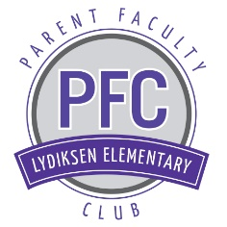
Lydiksen Elementary Parent Faculty Club
Nomination Form 2017-2018

The PFC Board is comprised of 9 parents/community members and the school principal. All board positions are open to the nomination process each year, even if a current board member is interested in returning. Each position may be held for a maximum of two, one year terms, provided the board member is re-elected. A brief description of the board positions can be found at Lydiksenpfc.org
Board members are required to attend one monthly board meeting and one monthly general meeting. Most members will attend majority of school events.
Nominations will be taken until 3/31/17. Please fill out this form and email to president@lydiksenpfc.org. Our current secretary will collect submissions and forward to the nomination committee for review.

Name _________________________________________________
Child(ren’s) name(s) ________________________ Grade(s) _____
I want to serve on the PFC as a ______________ because (A ballot statement is necessary if we need to hold an election. If necessary, you may attach a second sheet of paper to this form):

